Wisconsin Presidential Vote

The 2016 presidential election in the United States was a curious affair given the stark differences between the candidates. The main presidential candidates had opposing views on the major issues, causing a split in the vote which basically depended on the philosophies people identified with, such as being conservative or liberal. According to Hooghe & Dassonneville, (2018) this divide extended to become one of race. Since conservatives are predominantly white, Donald Trump got more votes from areas where more white people lived. In addition to race, this election illustrated a significant variation between rural and urban areas with rural areas in support of Trump. This study used the Besag, York, and Mollie model below to draw insights on which demographic factor was the most significant estimator of the vote in Wisconsin.

$$Y_{i}\sim Binomial\left(N_{i},ρ\right)$$

$$\log\left[\frac{ρ_{i}}{1-ρ_{i}}\right]=μ+X_{i}β+U_{i}$$

$$U_{i}=BYM(σ^{2},ϕ)$$

Where $Y_{i}$ is the number of votes cast for Donald Trump, $X_{i}$ is a vector of the proportion of the population which is white to the indigenous population and the population density. This was the most suitable model for this application for a number of reasons. It was very easy to fit to the spatial data because it was very straightforward and simpler than other feasible models. It was also very sensitive to the prior used such that the assumption could guide the posterior derived to fall within a certain range within. In essence, this prior guided the model in determining the sensitivity of the vote to the different factors which were taken as covariates in the calculation. In addition to these advantages, the BYM model enabled the study to benefit from the advantage of Bayesian inference over the frequentist approach.

This model showed robust results which coincided with the suggestions of various political sources. The table below shows the coefficients of the estimators of the votes Trump got in the 2016 election.

|  |  |  |  |
| --- | --- | --- | --- |
|  | 0.5quant | 0.025quant | 0.975quant |
| (Intercept) | -0.56276 | -0.82716 | -0.29674 |
| logPdens | -0.08105 | -0.08979 | -0.07232 |
| propWhite | 1.41879 | 1.15241 | 1.68307 |
| propInd | -0.78943 | -1.13430 | -0.44628 |
| sd | 0.31830 | 0.30419 | 0.33446 |
| propSpatial | 0.96016 | 0.91715 | 0.98591 |

As the table illustrates, propWhite had the largest coefficient, showing that it was the most important estimator of the votes Donald Trump would get. In contrast, propInd showed a strong negative correlation with the number of votes Trump would get. These two indications made the trustworthy implication that most white people preferred Trump while most of the minorities, represented here by the indigenous people would not vote for Trump. The log of the population density had a small and negative coefficient. This suggested a weak negative correlation between the population density and the number of voters who preferred Donald Trump. This implied that the population in the large urban areas of Wisconsin included more liberals than rural areas. However, the influence of race on the vote was more pronounced than the influence of rurality. As such, Trumpism in 2016 was a racial phenomenon which saw Donald Trump appealing greatly to white voters, hence his large win in Wisconsin.

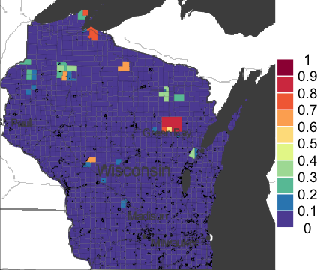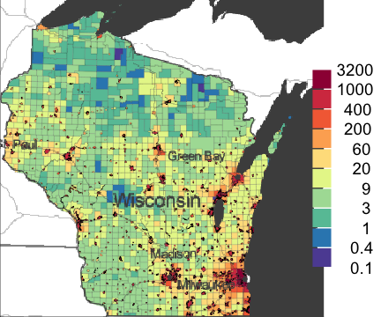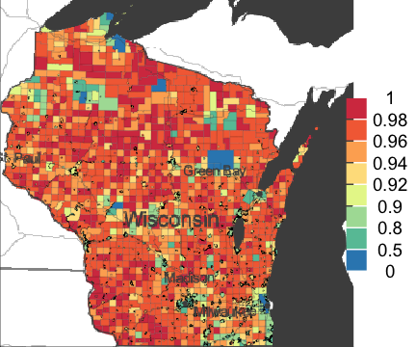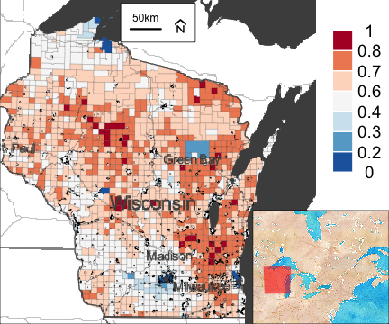

Although the model successfully explained the results of the presidential election in Wisconsin in 2016, it did not point to more influences such as sex and duration of citizenship. This casts doubts on its appropriateness. It also failed to show that immigrants and their families definitely had a negative perception of Trump due to his stance on immigration. Finally, it failed to sufficiently cover the matter of race, seeing as it only considered white people and indigenous people, leaving out all other races. These weaknesses may have caused the high standard deviation in the table above.

England COVID-19 Cases

The Coronavirus Disease 2019 has quickly become the subject of research for many professionals in many fields. The disease aggressively attacks the respiratory system, causing lungs to be filled with a fluid. The failure of the respiratory system has been the most common cause of death for COVID-19 patients. For this reason, equipment such as ventilators have achieved a higher demand than they have ever had. Due to the nature of this disease, it has been established that people living with respiratory comorbidities such as asthma are at an increased risk of infection and even death from COVID-19. As one would expect, respiratory diseases are more rampant in areas with ambient air pollution such as highly industrialized areas. They would also be more frequent in urban areas than in rural areas. This suggests that people living in areas with higher quantities of aur pollutants have an increased risk of getting infected with COVID-19 and even succumbing to it, seeing as their respiratory systems are compromised.

In an effort to explain this connection scientifically, Wu, et al., (2020) document a cross sectional study of the United States which used county level data to relate COVID-19 and long term exposure to air pollution. This study concluded that with a 95% confidence interval, an increase of 1 𝜇g/m3 of long-term average to $PM_{2.5}$, the COVID-19 death rate had an increase of about 8%. This study clearly showed the significance of long-term exposure to air pollutants on the mortality from COVID-19.

A Besag, York, and Mollie model was fitted to data in the United Kingdom in order to explain the relationship between air pollution and COVID-19 mortality. This model can be illustrated mathematically as follows:

$$Y_{i}\sim Poisson\left(E_{i}λ_{i}\right)$$

$$\log\left(λ_{i}\right)=μ+X_{i}β+U_{i}$$

$$U_{i}=W_{i}+V_{i}$$

$$V_{i}\sim i.i.dN(0,τ^{2})$$

$$W_{i}|\left\{W_{j};j≠i\right\}∼N\left(mean\left\{W_{j};j∼i\right\},\frac{σ^{2}}{\left|j∼i\right|}\right)$$

$$E_{i}=\sum_{k}{P_{ik}θ_{k}}$$

Where $Y_{i}$ is the number of COVID-19 cases, and $λ_{i}$ is a function of ethnicity, modelled level of air pollution, and unemployment. *Ui* is a spatial random effect, *Wi* is an improper GMRF and *Vi* is independent noise. As such, this study considered that areas which are mainly occupied by minority populations and unemployed people are more polluted on average. This is attributed to systemic racism which limits delivery of health services and enforcement of anti-pollution laws in these areas. As such, this model took into consideration that the demographic characteristic of a given area has a significant relationship with pollution and the rate of COVID-19 infection and mortality.

|  |  |  |  |  |
| --- | --- | --- | --- | --- |
|  | mean | 0.025quant | 0.5quant | 0.975quant |
| (Intercept) | -1.00751925 | -1.523288113 | -1.00723306 | -0.49379891 |
| Ethnicity | 0.01204782 | 0.008097690 | 0.01204645 | 0.01600188 |
| modelledpm25 | 0.05578866 | -0.004375153 | 0.05574960 | 0.11611600 |
| Unemployment | 0.11321387 | 0.057647691 | 0.11321298 | 0.16873306 |
| sd | 0.29402227 | 0.258725327 | 0.29304915 | 0.33554463 |
| propSpatial | 0.89801415 | 0.767852225 | 0.90705357 | 0.97547907 |

The results of the model had a high standard deviation, casting doubts on its accuracy. However, it did show a weak positive relationship between ethnicity, unemployment, modelled $PM_{25}$ and the rate of infection of COVID-19. The maps plotted after fitting this model showed a more significant relationship between these variables. As shown below, the pattern they have confirms the findings in Wu, et al., (2020).

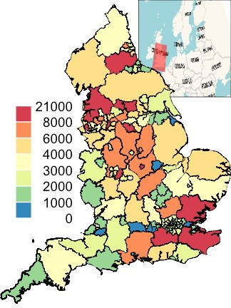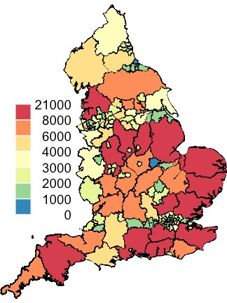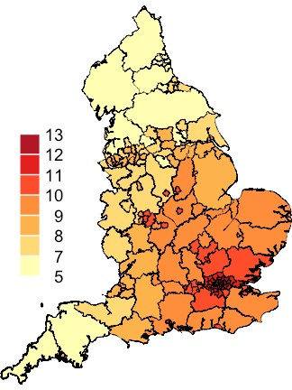

(a) cases (b) E (c) pm

References

Hooghe, M. & Dassonneville, R., 2018. Explaining the Trump vote: The effect of racist resentment and anti-immigrant sentiments. *PS: Political Science & Politics,* 51(3), pp. 528-534.

Wu, X. et al., 2020. Exposure to air pollution and COVID-19 mortality in the United States. *medRxiv.*

Appendix

Wisconsin

library("sp")

library("INLA")

theColTrump = mapmisc::colourScale(wisconsinCsubm$propTrump,col = "RdBu",

breaks = sort(unique(setdiff(c(0, 1,

seq(0.2, 0.8,

by = 0.1)),

0.5))),

style = "fixed",

rev = TRUE)

theColPop = mapmisc::colourScale(wisconsinCsubm$pdens, col = "Spectral",

breaks = 11, style = "equal", transform = "log",

digits = 1, rev = TRUE)

theColWhite = mapmisc::colourScale(wisconsinCsubm$propWhite,

col = "Spectral",

breaks = c(0, 0.5, 0.8, 0.9,

seq(0.9, 1, by = 0.02)),

style = "fixed", rev = TRUE)

theColInd = mapmisc::colourScale(wisconsinCsubm$propInd,

col = "Spectral", breaks = seq(0, 1, by = 0.1),

style = "fixed", rev = TRUE)

theBg = mapmisc::tonerToTrans(mapmisc::openmap(wisconsinCm,

fact = 2, path = "stamen-toner"),

col = "grey30")

theInset = mapmisc::openmap(wisconsinCm, zoom = 6, path = "stamen-watercolor",

crs = mapmisc::crsMerc,

buffer = c(0, 1500, 100, 700) * 1000)

mapmisc::map.new(wisconsinCsubm, 0.85)

sp::plot(wisconsinCsubm, col = theColTrump$plot, add = TRUE,lwd = 0.2)

raster::plot(theBg, add = TRUE, maxpixels = 10^7)

mapmisc::insetMap(wisconsinCsubm, "topright", theInset,outer = TRUE, width = 0.35)

mapmisc::scaleBar(wisconsinCsubm, "top", cex = 0.8)

mapmisc::legendBreaks("topright", theColTrump, bty = "n",inset = 0)

mapmisc::map.new(wisconsinCsubm, 0.85)

plot(wisconsinCsubm, col = theColPop$plot, add = TRUE, lwd = 0.2)

plot(theBg, add = TRUE, maxpixels = 10^7)

mapmisc::legendBreaks("right", theColPop, bty = "n", inset = 0)

mapmisc::map.new(wisconsinCsubm, 0.85)

plot(wisconsinCsubm, col = theColInd$plot, add = TRUE, lwd = 0.2)

plot(theBg, add = TRUE, maxpixels = 10^7)

mapmisc::legendBreaks("right", theColInd, bty = "n", inset = 0)

mapmisc::map.new(wisconsinCsubm, 0.85)

plot(wisconsinCsubm, col = theColWhite$plot, add = TRUE, lwd = 0.2)

plot(theBg, add = TRUE, maxpixels = 10^7)

mapmisc::legendBreaks("right", theColWhite, bty = "n", inset = 0)

theColRandom = mapmisc::colourScale(resTrump$data$random.mean,

col = "Spectral", breaks = 11,

style = "quantile", rev = TRUE, dec = 1)

theColFit = mapmisc::colourScale(resTrump$data$fitted.invlogit,

col = "RdBu", rev = TRUE,

breaks = sort(unique(setdiff(c(0, 1, seq(0.2, 0.8,

by = 0.1)),

0.5))),

style = "fixed")

mapmisc::map.new(wisconsinCsubm, 0.85)

plot(resTrump$data, col = theColRandom$plot, add = TRUE, lwd = 0.2)

plot(theBg, add = TRUE, maxpixels = 10^7)

mapmisc::legendBreaks("topright", theColRandom)

mapmisc::map.new(wisconsinCsubm, 0.85)

plot(resTrump$data, col = theColFit$plot, add = TRUE, lwd = 0.2)

plot(theBg, add = TRUE, maxpixels = 10^7)

mapmisc::legendBreaks("topright", theColFit)

knitr::kable(resTrump$parameters$summary[, paste0(c(0.5,0.025, 0.975), "quant")],

digits = 5)

England

library("raster")

library("diseasemapping")

library("sp")

UK2 = UK_shp[grep("Wight", UK_shp$Name, invert = TRUE),]

englandRes = diseasemapping::bym(cases ~ offset(logExpected) +

Ethnicity + modelledpm25 + Unemployment,

prior = list(sd = c(0.5, 0.5),

propSpatial = c(0.5, 0.5)),

family = "poisson", data = UK2)

casesCol = mapmisc::colourScale(UK2$cases, dec = -3, breaks = 12,

col = "Spectral", style = "quantile", rev = TRUE)

Ecol = mapmisc::colourScale(UK2$E, breaks = casesCol$breaks,

col = casesCol$col, style = "fixed")

pmCol = mapmisc::colourScale(UK2$modelledpm25, breaks = 9, dec = 0,

style = "quantile")

ethCol = mapmisc::colourScale(UK2$Ethnicity, breaks = 9,

digits = 1, style = "quantile")

uCol = mapmisc::colourScale(UK2$Unemployment, breaks = 12, dec = 0,

style = "quantile")

rCol = mapmisc::colourScale(englandRes$data$random.mean, breaks = 12,

dec = -log10(0.25), style = "quantile")

fCol = mapmisc::colourScale(englandRes$data$fitted.exp, breaks = 9, dec = 1,

style = "quantile")

insetEngland1 = mapmisc::openmap(UK2, zoom = 3, fact = 4,

path = "waze", crs = CRS("+init=epsg:3035"))

insetEngland = raster::crop(insetEngland1,

extend(extent(insetEngland1), -c(25, 7, 4, 9.5) * 100 * 1000))

mapmisc::map.new(UK2, 0.85)

mapmisc::insetMap(UK_shp, "topright", insetEngland, width = 0.4)

plot(UK2, col = casesCol$plot, add = TRUE, lwd = 0.2)

mapmisc::legendBreaks("left", casesCol, bty = "n")

mapmisc::map.new(UK2)

plot(UK2, col = Ecol$plot, add = TRUE, lwd = 0.2)

mapmisc::legendBreaks("left", casesCol, bty = "n")

mapmisc::map.new(UK2)

plot(UK2, col = pmCol$plot, add = TRUE, lwd = 0.2)

mapmisc::legendBreaks("left", pmCol, bty = "n")

mapmisc::map.new(UK2)

plot(UK2, col = ethCol$plot, add = TRUE, lwd = 0.2)

mapmisc::legendBreaks("left", ethCol, bty = "n")

mapmisc::map.new(UK2)

plot(UK2, col = uCol$plot, add = TRUE, lwd = 0.2)

mapmisc::legendBreaks("left", uCol, bty = "n")

mapmisc::map.new(UK2)

plot(UK2, col = rCol$plot, add = TRUE, lwd = 0.2)

mapmisc::legendBreaks("left", rCol, bty = "n")

mapmisc::map.new(UK2)

plot(UK2, col = fCol$plot, add = TRUE, lwd = 0.2)

mapmisc::legendBreaks("left", fCol, bty = "n")